**Masterpieces**

A Soule

It’s not an exaggeration to say that we spend most of our time trying to sort out the here and now of our daily lives. Routines of the day slip into months and months to seasons, and the years slip by. But what if we were able hold a moment in time for us to gaze and ponder at our leisure? A work of art, does just that.

One can pass by many famous paintings in a gallery, never really thinking about them but the memory of just some paintings can haunt you a long while. A painting, however, doesn’t give up its secrets at first sight. What one sees on the canvas is much more than what the eye can see at a particular moment; for the painting also captures how the artist feels about the subject being drawn. This is where the genius of an artist is observed.

A true masterpiece stays in your consciousness, speaks to you across time and space; usually after the artist and the subject of the painting have long gone. It has the capacity to recreate the mystery of an event or an object so successfully that it touches something deep in ourselves and hints at unexpressed thoughts.

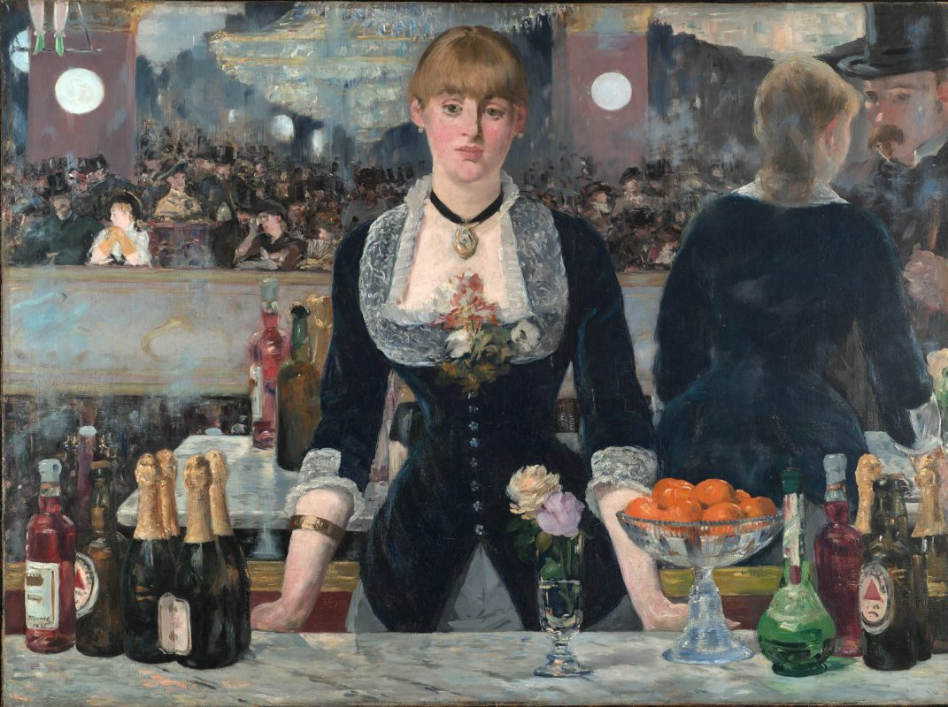

Painting by Edouard Manet (created in 1882)

The painting by Manet of the barmaid is one of those where the scene and the personages painted are never really forgotten by someone who has gazed at it long enough. The painting is well known and there is already a lot of critical commentary on who the girl painted actually was and the place. But to appreciate the painting one needn't go into what is not actually painted by the artist - what really matters is what is shown or hinted at in the painting itself.

The expression of the barmaid speaks of a mind at unease and yet an acceptance of her situation, whatever that may be. She is unsure of herself; of whether she needs to be where she is. The bustling excitement around her (shown only in a mirror behind her) seems to leave her untouched. There is a sadness in her eyes, which is quite in contrast with the general atmosphere of the place. Something in her tells her that at the end of the road, there is sorrow.

Whilst critical opinion on Manet as a painter can be divided, there is no doubt the painting is striking and can haunt our imagination for long.

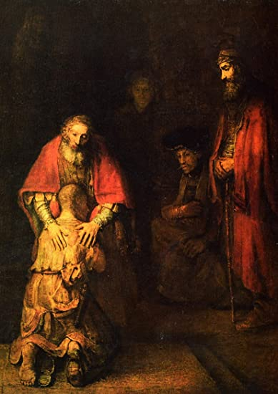

Rembrandt's painting of the prodigal son (created between 1663 and 1669)

Another painting which can surprise one by its sheer emotional intensity is that of Rembrandt's Prodigal Son, based on the well know parable described in Luke's gospel. What is striking is that we don’t see the face of the prodigal son, all we see of him is his back and his bent head. The shape of the body from behind is enough to convey the wayward son's deep repentance, and the realisation that he now has no right to anything but to plead for his father’s mercy.

The expression on the father's face is that of pure love; looking over any judgement of what the son had done or deserved. The painting also shows the older brother looking on at the scene in awe of his father’s love for the brother who has returned. Clearly the scene shown is after the father has explained to the older son his reasons for welcoming his brother. He understands that for him to love his father (which he does) would also mean loving his repentant brother - whom his father loves dearly.

Anyone aware of the Biblical context of the story will understand. that the forgiving father in the parable stands for God and the repentant son for all those returning to His fold. One can see how well Rembrandt rises up to the challenge of depicting the actual narrative along with imaginatively hinting at the wider theological context. The painting is purely an artist’s vision, and is no substitute for the actual narrative in the Gospel. But it is clear that the artist has delved deeply into what the story is about.

The expression of love and forgiveness on the father’s face and the figure of the repentant son in tattered clothes is something that stays with you long after you have moved from the painting. For this is about homecoming, the son has traversed the crossroad faced by the girl in Manet's painting, and concluded this is where he needs to be, under his father’s protection. A true masterpiece no doubt.