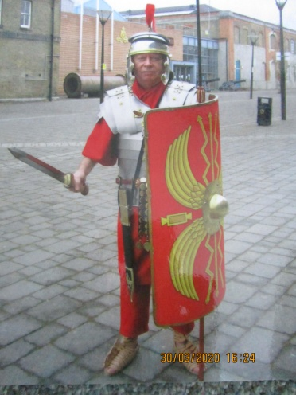

I was reminded of the visit to Esme's school when Ephesians 6 verses 10-20 was given to us in our Daily Bread bible readings recently. The subject of the passage is "the Armour of God". After reading the passage I went into our office to look at the photo of me dressed in my legionaries’ outfit. This well-known passage uses the various components of a suit of armour of the time - presumably Roman, as a visual aid to various aspects relating to the Christian Life: -

The breastplate           righteousness

Footwear                    readiness to spread the good news of the Gospel

Shield                         faith

Helmet                        salvation

Sword                         ...of the spirit - the word of God

Belt                             Truth

We need to put on the Armour of God to deal with this virus that is affecting our lives.

In this passage, Paul tells the Ephesians to pray in the Spirit on all occasions using all kinds of prayers and requests. Now is the time to "bombard" God with our pleas to end the spread of the Coronavirus.

Bob Lindridge

A few months ago, I went to my Granddaughter Esme's school to talk to her class about life as a Roman soldier. They were studying the Romans in their history lessons. They really enjoyed meeting a real live Roman legionary and had lots of questions to ask. Esme's school is very close to where they live but has no parking facilities. This meant that I had to change in Esme's house and walk to her school. People who I passed on my way were very amused.

**The Armour of God**