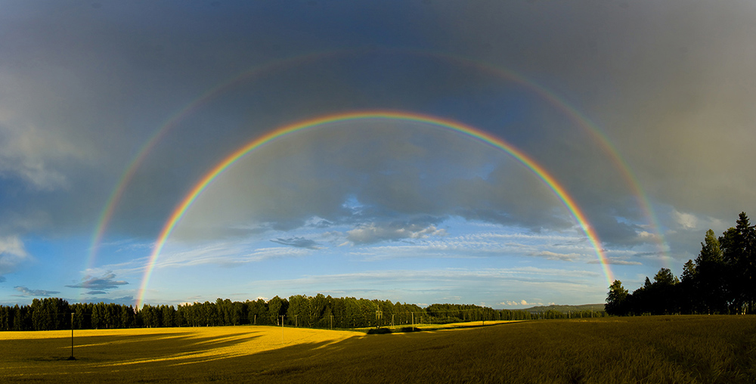

Looking for Rainbows by Judy Smith

Reading Lauraine's answer to the question Colin and I posed about how Noah fed the animals on the ark, I was suddenly struck by the similarity between his situation and what we are experiencing. His whole world had been turned upside down, just as ours is now. He'd stockpiled dried food (pasta!) and he probably worried that he wouldn't have enough to feed everybody, because like us, he didn't know exactly how long he would be in isolation for. He had no need to panic about stockpiling toilet rolls, sanitary arrangement being somewhat different in his situation! Although Noah may have had momentary doubts and worries, he knew that God would never let him down. He trusted God and knew He would be with him throughout this difficult time. His faith was strong. When the flood eventually subsided and the land was dry again God chose as His symbol of hope and promise a beautiful rainbow.

Today, in the midst of our crisis pictures of rainbows are appearing in windows everywhere, as signs of hope and gratitude to the people who are risking everything to help us in so many ways. This was originally meant to be a fun game for children prevented from going to school, but has come to mean so much more. We all know the 7 colours of the rainbow, but rainbows actually contain many more colours, not visible to the human eye. If the visible colours represent our human visible help, then wouldn't it be lovely to think that the colours we cannot see, but know are there, represent our loving and ever present God? He is in the crisis with us, we cannot see Him but we can feel His presence.

